Web Automation (IS and Apps) - Automated Test Development Guide
For Script v3.x
Author: QA Web Automation Team

Table of Contents
1 Table of Contents 2
2 Introduction 3
3 Picking the framework from TFS or Local Builds 4
3.1 Approach for starting the development 4
3.2 Approach for picking the build 4
3.3 Profiles 4
3.4 Test Cases and Object Repository 5
3.5 Test Suites 6
3.6 Data Files 6
4 Keywords and Listeners 7
5 External Libraries required 8
6 Structure Explanations 9

Introduction

- This document explains operational factors to be considered before/during development of Automated tests for Apps based on Platform or general Web Applications, using the Katalon Studio framework developed by QA Web Automation Team.
- The reader of this document is:
  - Expected to be aware of concepts/basics of Test Automation + Katalon Studio tool + Selenium and WebDriver.
  - The reader should have automated some tests using Katalon Studio on his/her side, for some common web app flows for the Application Under Test.
  - Expected to be well versed with Katalon Studio Test Execution recommendations suggested by QA Web Automation Team:
    - Refer document “Web Automation (IS and Apps) - Automated Test Execution Guide.docx”.
    - Refer guiding videos (training conducted by QA Web Automation team)

Picking the framework from TFS or Local Builds

Approach for starting the development

Generally, you could encounter two scenarios:
- You need to start using the IS 6.0 framework and tailor it to your needs
- You have already done above step, but you need to have an update
Guidelines for this are explained in next point.

Approach for picking the build
Automation Framework (Along with IS 6.0 Scripts) can be picked from following two locations.
- TFS Path where IS 6.0 Automation framework is residing
  - $/QA Automations/IdealSpacesAutomation/IdealSpaces 6.0/Script v3.x
- Local Builds
  - \\pc-win7qa64.apac.wan.2020.net\QA Web Automation\Builds\Local Builds

However, there are some important points to be considered.
- When you want the latest changes done by Automation team, you can “Get Latest” from the TFS location shared above. But the latest changes need not necessarily be fully tested from our end, so we do not recommend this at this stage.
- QA Web Automation team will signal the build to be picked up.
You can pickup the same from Local Builds area, which are normally the sufficiently tested builds from Automation team.
You can consult with QA automation team, to know an “approximate change log” w.r.t. version you have.

Once you get/copy the build, you can have two situations as explained in 3.1.A or 3.1.B.
For both cases, refer below documentation to know which files, folders are areas of the framework are reusable and need to be considered non-editable + non-modifiable in any way.


Profiles
- When using IS 6.0 automation framework, you need to set at least one profile for your app.
Profile Variables (aka Global Variables) are used by some common keyword files, as well as listener files.

- To Setup Profile for your app, just copy paste any existing profile and rename it.
In this profile, you will need to edit below variable(s) in its basics.

- testDataSheetName:
This variable indicate the program, that from which xls sheet the input data for your app needs to be fetched.

Note: Refer Test Data section later in Doc, to see how to setup input data sheet xls for your app.

- It is recommended to avoid any new global variables in the Profiles. If absolutely necessary, you can. We would advise you to discuss this special handling with QA Web Automation team though, so that the future approach could be decided around this.

Test Cases and Object Repository

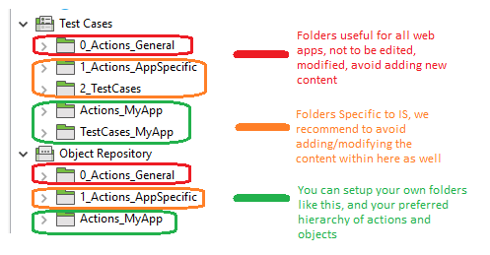
- While creating reusable actions, we recommend to use meaningful/context specific names.
- The folder hierarchy used on Actions side, can be maintained under Object repository as well.
This helps in tracing back the objects used within actions.
- While creating test objects, we recommend:
  - Along with other attributes (which is optional for you), at least add an xpath attribute.

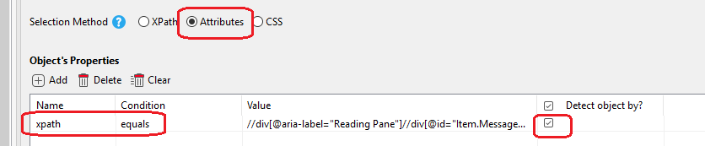

  - Name the test objects with following fashion.
<html element type>_<context specific explanation of object>

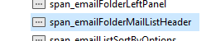

Test Suites

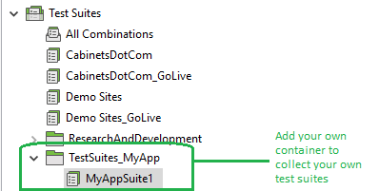

Data Files

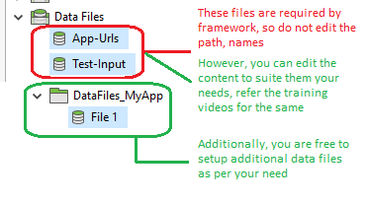

Keywords and Listeners

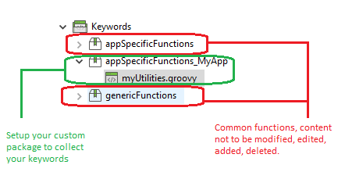

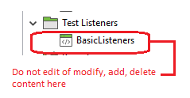

External Libraries required
You must retain the content inside External Libraries. They are the dependencies for some functionality being used via Keywords and Listeners.

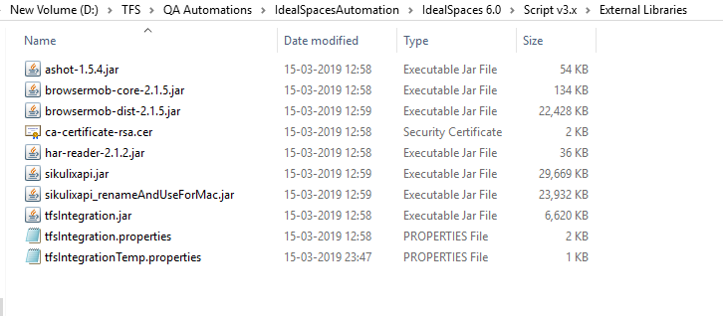

The TFS integration properties file (tfsIntegration.properties) needs to configured based on your project test reporting needs. Please consult with QA automation team to know the configuration parameters.

Structure Explanations

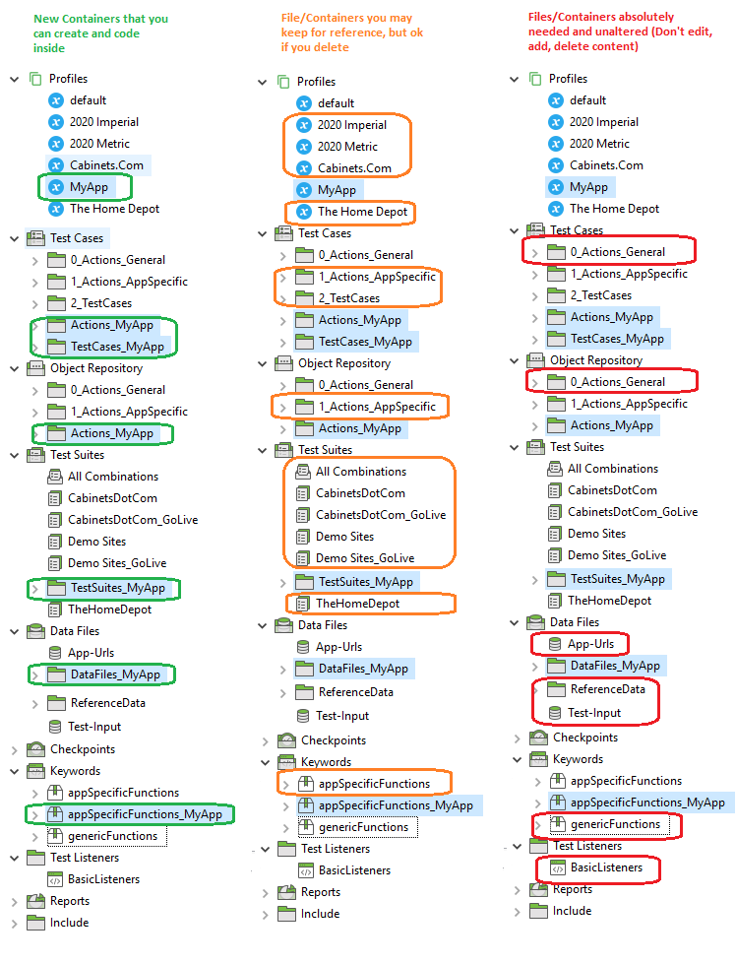

Some simplified representations

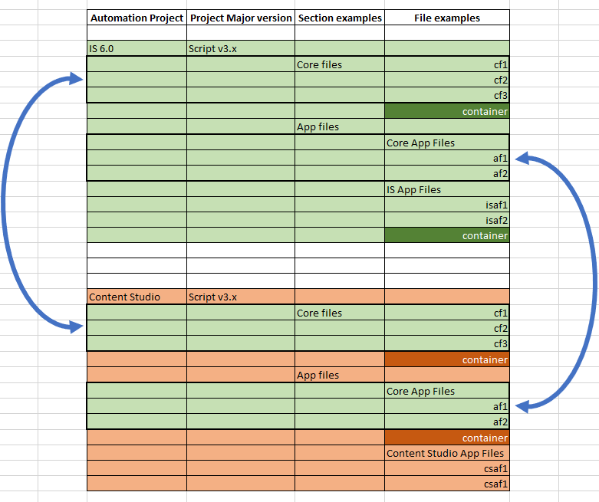

- Distribution to "Consumers”
  - Other teams requiring core keywords
  - Members requiring IS App lib actions

- TFS code storage proposal
  - For 1.A:
    - Separate projects in TFS
    - Identification of core/common files
    - Constraint for Consumers -> These files should not be edited/altered by "Consumers"
    - Constraint for Automation team -> We need to maintain the contract for functions present in these files
    - File Distribution signal will be triggered by QA Automation team
    - One person from QA Automation team can help integrate the changes

  - For 1.B:
    - Same project in TFS as that of IS 6.0
    - Containers for specific developments by consumers
    - Their development can happen inside these Containers
    - If consumers need some specific changes in the code/script files outside their containers, they need to be approved by QA Web Automation team
    - The data/observation generation can either happen in "Reports" section, or outside project folder
    - The data/xls file they want to have, can be separate from the mainline data sheet

